**Lab#6:**

**Objective:** To learn RMI-IIOP

**Task#1:** Create RMI IIOP application in which take a sentence at runtime on the client application and let the server return its reverse.  
E.g. input could be: subject is distributed computing   
output should be: computing distributed is subject.

**Interface:**

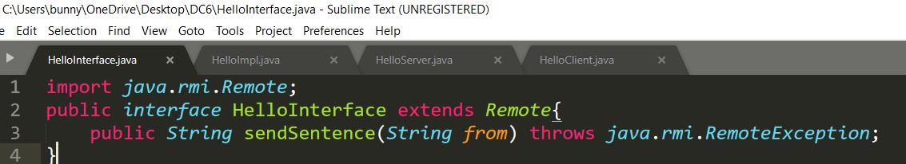

**PortableRemote:**

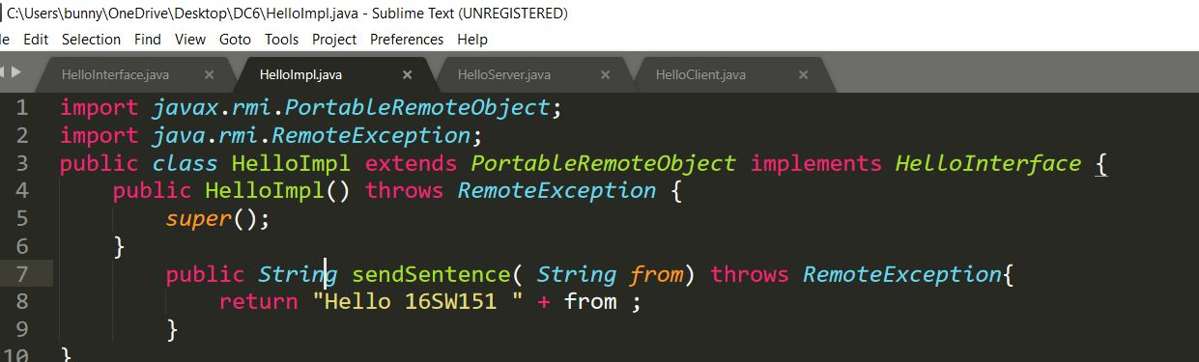

**Server:**

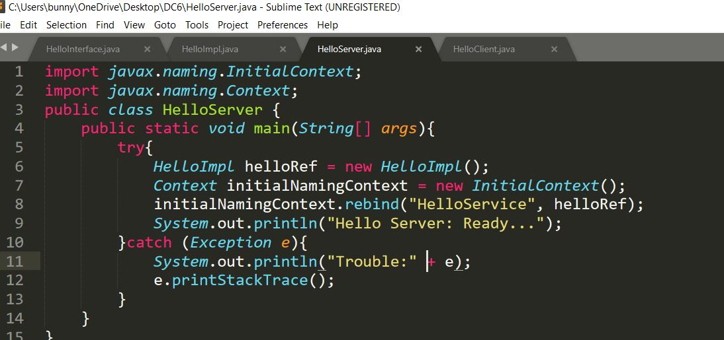

**Client:**

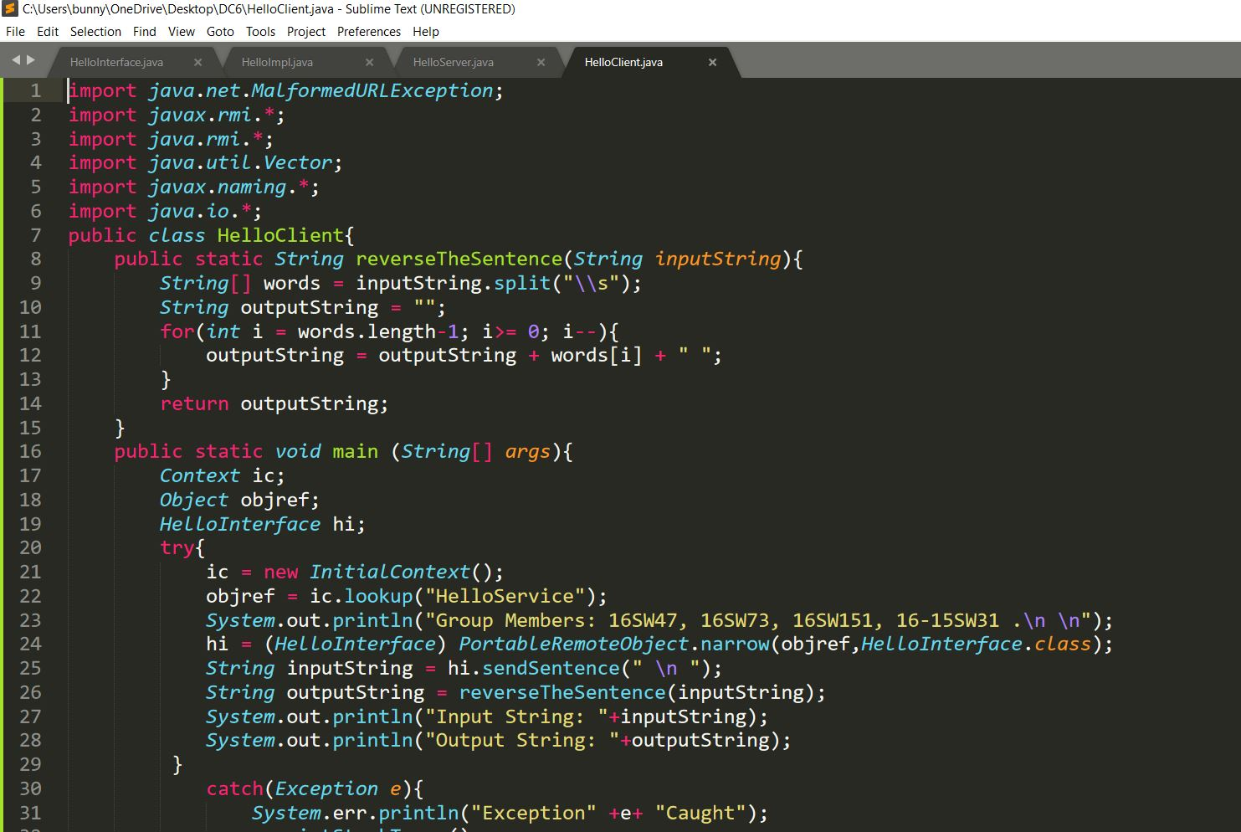

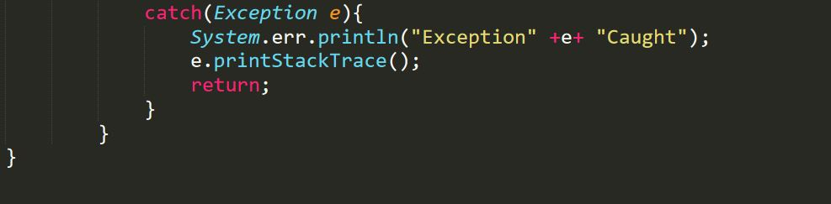

**Output:**

